EXTERNAL COLOUR & FINISHES SCHEDULE
PROJECT DETAILS |  | DATE | 06/03/2026
PROJECT ADDRESS | 49 Balls head road, Waverton | DEADLINE | Prior to CDC Approval  Required or BASIX Assessment
PROJECT NAME | BALLSH49 | CLIENT NAME | Benjamin & Jordan Sutton

1 | Please enter your selection in the table below
2 | Please read all the information in this document, sign and return before CDC approval to admin@horizonhomes.com.au.  Please note: If not returned by this time an extension of time will be claimed on the job which could delay your build time.

PRODUCT | RANGE / PROFILE | COLOUR | LOCATION | IMAGES | NOTES | V
COMMON BRICKS | PGH  Common Brick |  | All External |  | Acrylic render and paint finish
MORTAR COLOUR |  | STD Cement | All External
MORTAR JOINT TYPE | Flush |  | All External
RENDER | - | Dulux Grey Pebble ½ Strength S14B1H |  | 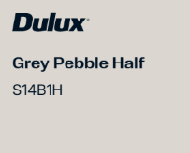 | Brick Veneer and EPS walls
WINDOW BANDS / MOULDINGS | - | N/A
CLADDING | Hardies Scyon Axon 133mm Smooth finish | Monument | West elevation |   
ROOF TILES | N/A
ROOF SHEETING | Kliplock profile | Surfmist | 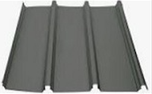 | 
PARAPET CAPPING | Colorbond | Surfmist |  | 
FASCIA | Metal fascia | Monument |  | 
GUTTERING | Round line Flatback half round slotted gutter | Monument | 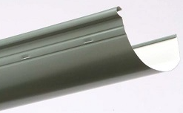 | 
DOWNPIPES | 90mm Diameter PVC painted | Dulux Grey Pebble ½ Strength - S14B1H |  | 
EAVES LINING | - | Dulux Grey Pebble ½ Strength - S14B1H |  | 
TIMBER POST |  | Monument | Porch x3  Balcony x3 |  | Timber posts to the Porch and balcony  3x 180x65 (Nominal) Dressed timber post
WINDOW & DOORS (Aluminium) | Powder coated aluminium windows | Monument |  | 
WINDOW HARDWARE (Locks, Winders etc) | Black |  |  | 
OPTION 1  EXTERNAL DOOR (Other – Aluminium) | Hinged door | Monument | Laundry Door |  | A doggy door can be installed in the glass of an aluminium door if this option is preferable
OPTION 2  EXTERNAL DOOR (Other – Aluminium) | Hume Entrance Door XF3  Translucent Glass | Dulux Grey Pebble Half S14B1H | Laundry Door | 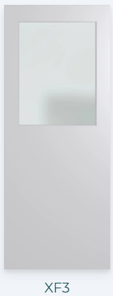   | Colour has a LRV greater than 50  NOTE: CLIENTS HAVE SELECTED THIS TIMBER DOOR FOR THE LAUNDRY, TO ALLOW THEM TO INSTALL A ‘DOGGY DOOR’ AFTER HAND OVER  NOTE: THIS COLOUR WILL ALLOW THE DOOR TO BLEND IN WITH THE WALLS
GARAGE DOOR | B&D Panelift Garage Doors  Madrid Profile  Woodgrain Finish | Monument |  | 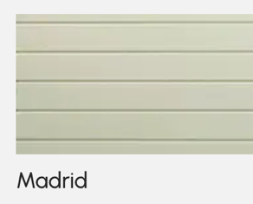 | Madrid Profile  Woodgrain Finish
ENTRANCE DOOR | Hume Savoy SX45 Entrance Door Sliced Pacific Mample (SPM) (2340x1200x40) | Clear Stain  Clear glass | Front door | 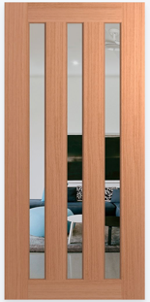 | Colour has a LRV greater than 50
SIDELIGHTS  (If applicable) | N/A
BALUSTRADING  (to Front Façade) | 12mm Toughened Glass with U-Channel | Powder coated Aluminium  Monument | Balcony | 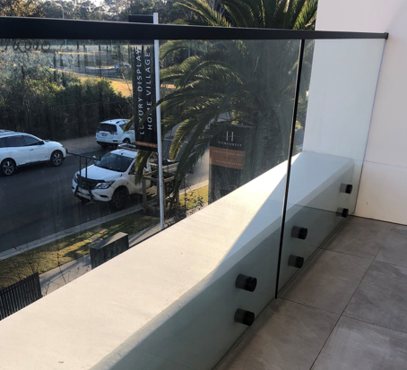 | Powder coated aluminium with 25yr powder from Interpon or Dulux due to salt water proximity.
EXTERNAL STAIRS (South elevation) |  | Concrete stairs  Tile finish |  |  | Refer to tile selections for the tiles in this area
EXTERNAL STAIRS BALUSTRADING  (South elevation) | External stairs | Powder coated Aluminium  Monument | Panaroma Style |  | Powder coated aluminium with 25yr powder from Interpon or Dulux due to salt water proximity.
EXTERNAL VENETIAN BLIND |  | Monument | West elevation Outside Guest bedroom (W20) |  | PA #15 - LLV80 Motorised exterior blind to the  First Floor – Guest room
PRIVACY SCREEN | Powder coated aluminium 70 x 16mm slat screen | Powder coated Aluminium  Monument | Balcony | 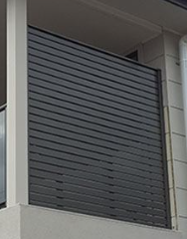   | Powder coated aluminium with 25yr powder from Interpon or Dulux due to salt water proximity.
VERGOLA |  | Surfmist |  |  | Provisional Allowance #8 – Details TBC further in the process  S&I Lifestyle Louvres 200mm motorised opening roof complete with wind  sensor

COMMENTS & QUESTIONS:

CLIENT ACKNOWLEDGEMENT

I/We have met with Horizon Homes representative and agree to the selection as made above. We are aware that any changes made at a later date may incur costs and an extension of time which could delay the build.

I/We acknowledge that the choice of suppliers is at the Builders discretion and that the Builder shall ensure that the colours chosen will be the same as or similar to those chosen in the selection form. In the event that a specified material in unavailable due to change of supplier the owner agrees to make any required reselection and subsequent variation to substitute the material.

I/We acknowledge that in regards to our brick selection that there is a natural variation in fired clay products affecting their colour, shade, texture & composition. We are aware that the brick chosen, may have variations in colour, shade, texture & composition which are inherent in fired clay products.

Signature: |  | Date:
Name:
Signature: |  | Date:
Name:

